TDTMS Meeting
September 21, 2026, 10:30 AM
WebEx only
Attendee | Company | Attendee | Company |  | Attendee | Company
Dave Michelson | ERCOT | Heverton Ferreira |  | Grid Monitor | Chris Gayhart | CIM View
Sheri Wiegand* | Vistra | Vikrum Gupta* |  | ERCOT | Rob Bevill* | TNMP
Elizabeth Morales* | ERCOT | Vaibhav Parekh |  | New Project Media | Ayca Argetsinger | AEP
Mike Dameron* | ERCOT | Kyle Patrick* |  | NRG | Sif Ali | Just Energy
Monica Jones* | CNP | Jim Wade |  | Vertex One | Cindy Duong | Just Energy
Jesse Macias | AEP | Edelmira Pena |  | Revolution | Livia Scarassati | Just Energy
Amy Sue Stirland | LP&L | Angela Ghormley |  | Calpine | Bill Snyder | AEP
Viviana Valdez | LP&L | Dale Gibbs |  | Just Energy

Sheri Wiegand opened the meeting, read the anti-trust admonition, and introduced attendees.
Minutes from the 7/28/26 meeting were reviewed, Action Items were addressed, and minutes approved as posted.

ACTION ITEMS:
- Dave was going to look into the logic for the deletes on the listserv – x bounce-backs over y time. Over a 10 day period, 20 bounce-backs are received
- ERCOT will propose language for the RMTE User’s Guide for instructions on how to obtain access. Dave reported this is ‘work in progress’ as multiple teams are responsible.
- Dave was to investigate posting the ‘data dump’ to MIS as a public report or if an SCR would be required. Dave explained there are two options:
  - Easier solution – posting one/two months of data on ‘retail operations’ page for a limited period of time, then data will “roll”. Page is controlled by Dave’s team. Downside is the data cannot be recreated and would need to be downloaded when posted.
  - Higher level of effort solution – SCR – straight-forward yet more “red tape” associated – emil #, assigned, regulatory review, governance process

ERCOT Updates

2027 SLAs
Release calendar is available. Vikram will be presenting 2027 dates to RMS. Vikram explained the Listserv and Market Data Transparency SLAs are now owned by Jamie Lavas’ team. There will be further discussion, likely at RMS, where and who will own the SLAs – TWG or another working group. Sheri reminded this was a previous discussion and it was recommended earlier that TDTMS have purview of this SLAs as it is impacting to the Retail space.

IT Report & SLAs
- Vikrum presented the August IT report noting all SLAs were met, site failover was conducted on 9/13, and a retail access(digital certificate) issue occurred on 9/9 where database reached maximum capacity. A market notice went out on 9/11. TWG will review incident at TWG this Thursday, 9/24 @ 2:00. Follow up note from TWG presentation: DCs were rejecting @~9:00 am when a cert revocation list was not refreshing. @ 11:00 am the cert revocation check was set to ignore and allow access. By 2:00 pm the DCs were resolved. ERCOT IT will be monitoring for any gaps to avoid future occurrence.

- The following graph were presented (now available since the recent upgrade… essentially the dark spots represent a controlled restart. API MT continues to perform well after monitoring every 5 minutes and reporting degradation as opposed to the 30 minute previous tracking.

- 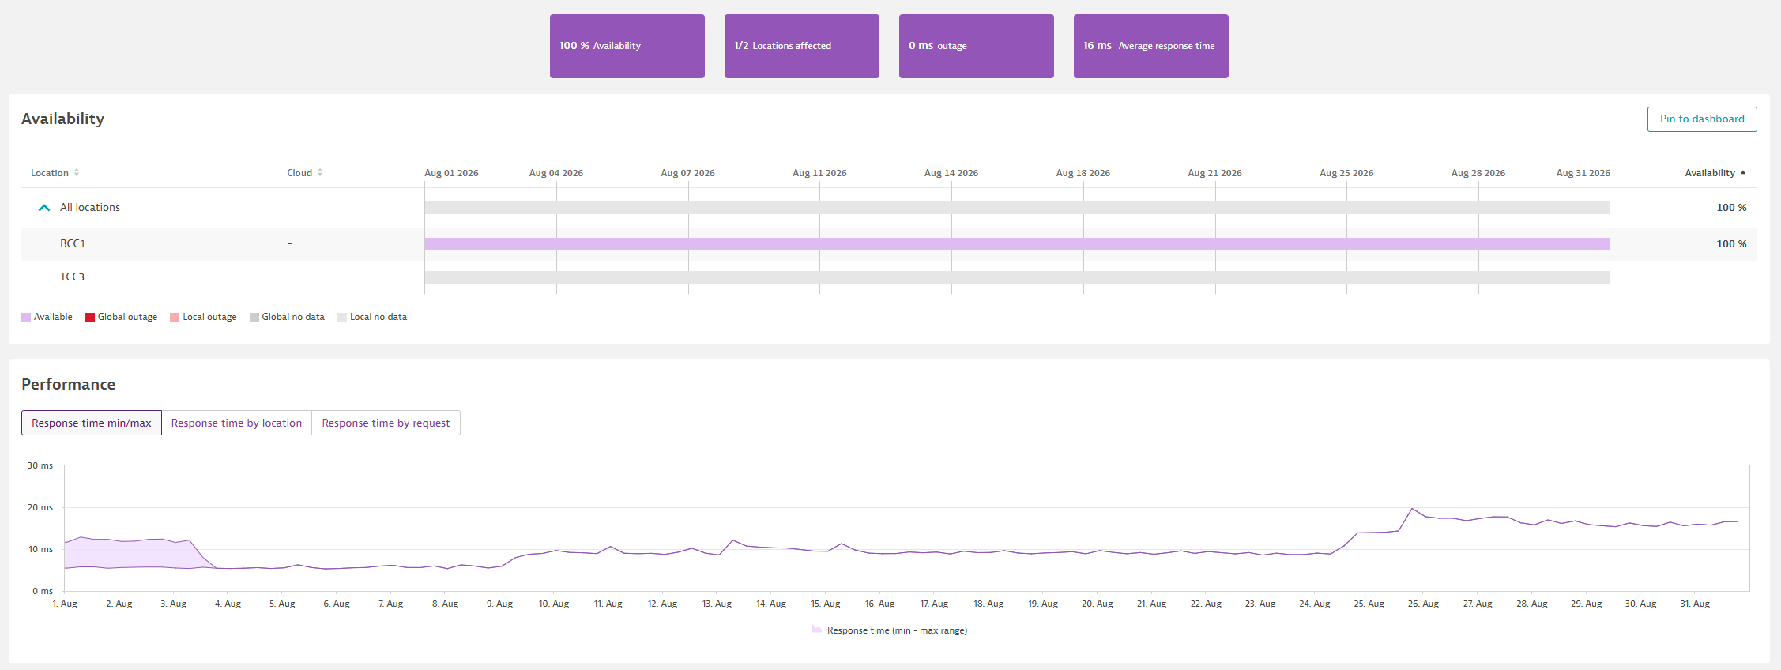

- 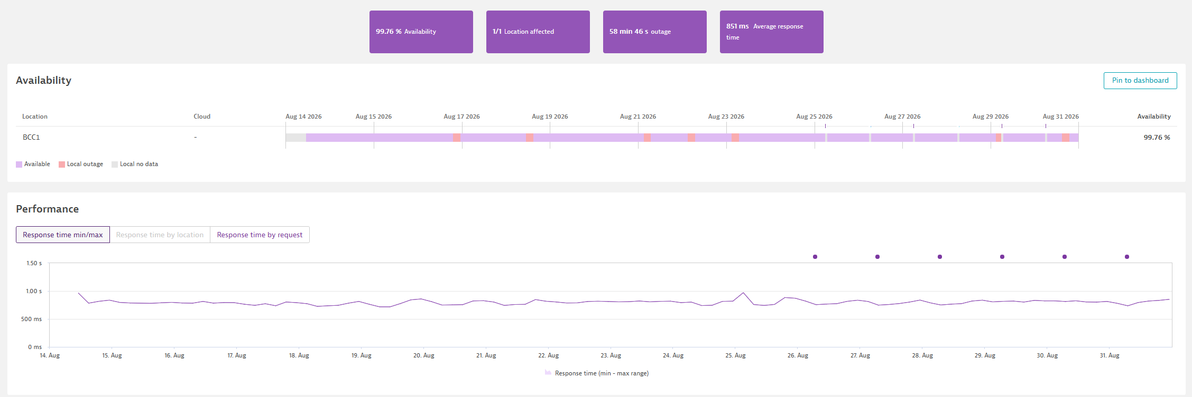

ERCOT IT Projects
- New Listserv Platform – Shawn Scott will be the ERCOT owner for the new Listserv platform under Jamie Lavas. Updates will likely be presented during TWG meetings.
- Client Services – Market Participant Service Portal (MPSP) – as described as part of the “blob” of access strategy for market participants with the goal of “one stop shopping” for stakeholders: ERCOT data/access, MPSP: Service Now, Batch Zero, etc with a single sign on. Once this project completes, this will drive future projects such as the MarkeTrak and FlighTrak alternative platform. Most will be discussed during TWG updates, however, Dave has committed to providing updates to TDTMS.

TDTMS MarkeTrak Enhancements List
Sheri pointed out the list of enhancements remains a working document where additional ideas can be presented.

Quarterly Review of IAS Report and Client Services
After reviewing the latest IAS report (May data) with a summary of historical data (see slides below), the question was raised “what are we doing about IAS?”. Sheri indicated MarkeTrak IAG ERCOT training can be effective for REP awareness of their performance and the nuances of working IAG issues. TDTMS will continue to partner with Client Services to socialize REP #s to REPs who may not have an active participant role in the stakeholder process.
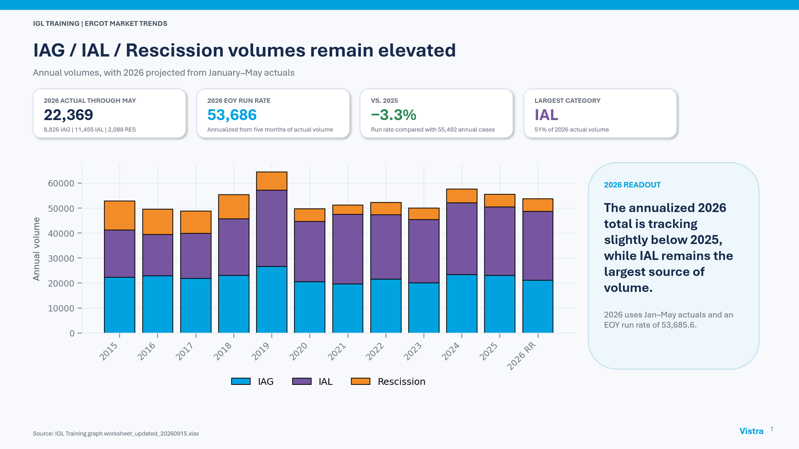
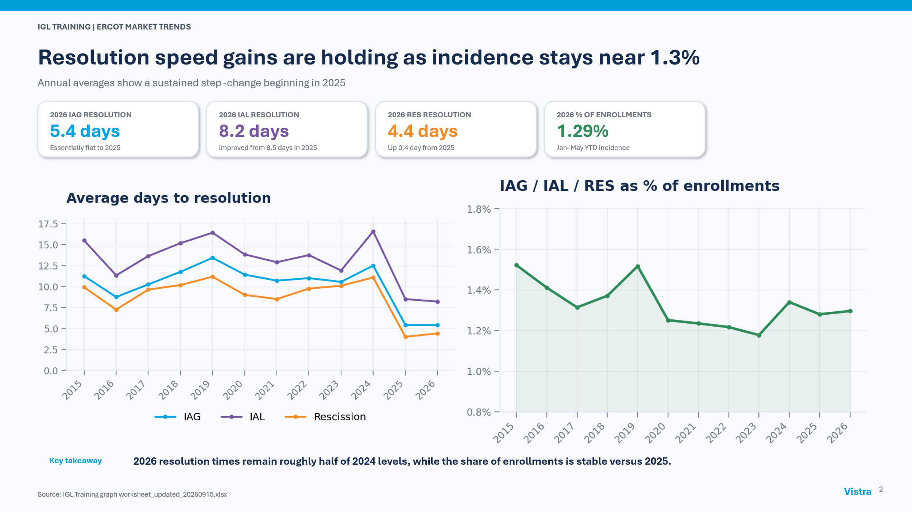
One suggested MarkeTrak enhancement is to begin tracking why IAS occurred/root cause of issue with a drop down within the MT with possibly the following root causes:
- Customer provided wrong information
- D2D enrollment
- Invalid agreement
- Same day cancel
- Oops
- Address is incorrect – repeated MTs @ address
Further discussion can be had on suggested efficiencies for the IAG process.

MarkeTrak Total Volumes by Subtype for 2026(1)
Summarizing observations:
- IAG/IAL/Rescission now make up a little over 60% of MTs submitted, although volumes have decreased ~4% from the first half of the year
- Total issues volume decreased to 59, 435, the lowest across the six half-year periods
- Switch Hold Removal remains seasonal – higher volumes first half of the year lower the second half
- Usage & Billing – Missing saw an increase of ~1500 cases
- Customer Rescissions saw an 8.7% increase from second half of 2025
- Meter Cycle Change Requests continue to see solid use although decreasing 18.5% from the second half of 2025
- Cancel w/Approval MTs saw a slight increase over second half of 2025, yet still within range over last six periods reviewed.

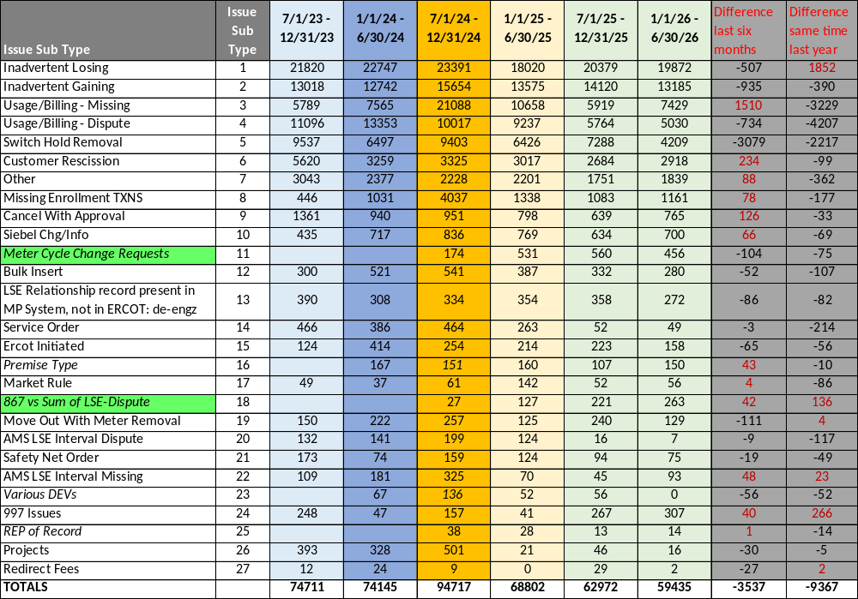

MarkeTrak Deep Dive – leveraging AI update
The smaller group met on 8/11 and 9/23 to continue efforts to develop prompts for market participants to leverage. The goal is essentially to recreate the same analysis the team has been providing over the last few years on market participant performance regarding issuing and processing of MarkeTraks.

Thus far, the prompts have been productive resulting in the same data as the manual efforts. The group will continue to meet to create the prompts and then test them on the new “data dump” of 2026(1) data. Any participants are welcome. Our next meeting is after RMS on Tuesday, October 13th where both an in-person and WebEx will be available.

TDTMS Meeting Date
Monday, October 26th @1:30 PM
No further dates have been selected

DRAFT AGENDA for October 26th meeting – 1:30 PM, Monday
- ERCOT Updates
  - IT Report
  - MT performance issues
  - 2027 SLAs
  - Projects
    - Client Services – Market Participant Service Portal
    - Digital Certificates / Access Management update
    - Listserv Platform
- MarkeTrak Enhancements list – updates
  - Discuss IAG suggested drop-down
  - Other ideas
- Client Services update on IAG support
- MT Deep Dive – review Rescission results of 2025(2)
- MT Deep Dive – leveraging AI update
  - “data repository” options
- Review of 2026 goals - checkpoint

